|  |  |
| --- | --- |
| cetlogo ***CHEMICAL ENGINEERING TRANSACTIONS***  ***VOL. xxx, 2024*** | A publication of  aidiclogo_grande |
| The Italian Association  of Chemical Engineering  Online at www.cetjournal.it |
| Guest Editors: Valerio Cozzani, Bruno Fabiano, Genserik Reniers  Copyright © 2024, AIDIC Servizi S.r.l. **ISBN** 979-12-81206-11-3; **ISSN** 2283-9216 | |

Risk Management In Energy Storage Using Lithium-Ion Batteries: Emerging Risks Associated With Bess Systems

Fabrizio Vazzanaa, Luca Fiorentinib\*, Fabio Dattiloc, Nicolò Bertelettib

aISPRA, Rome

bTecsa s.r.l., Pero, Milan, via Figino 101, 20016

cUniversità di Padova, Padova, via 8 Febbraio, 35122

\* luca.fiorentini@tecsasrl.it

Starting from the evaluation and management criteria typically used for quantitative risk, extensively employed, primarily for the so-called "risk industrial” and by employing the preliminary hazard analysis techniques most widely used, it was possible to provide an overview of potential industrial safety and environmental risks that can be associated with Lithium-ion Battery Energy Storage Systems (BESS) units including indirect and domino effects. In particular, a bow-tie analysis has been developed considering a typical BESS installation and, among the credible scenarios evaluated, two of them are presented: the oil-filled transformer fire scenario and the explosion inside the BESS. Work focused on safety aspects while results showed that environment assessment should be put in place to deal with the potential impacts, especially those coming from safety scenarios in terms of firewater on the soil and off-gases dispersion.

* 1. Introduction

BESS refers to an electrochemical device that can convert electrical energy into chemical energy or vice versa, and promises a cleaner future, enabling the efficient capture and deployment of renewable energy. However, recent incidents involving these systems, particularly fires and explosions that originate from thermal runaway, highlight the need for a systematic evaluation of emerging risks. As the number of BESS installations grows, it is crucial for operators to meticulously assess potential hazards related to the production of hazardous substances during accidents.

Beyond fires and explosions, potential risks include the formation of toxic and flammable off-gas dispersions, along with complex water management challenges during incident response due to fire suppression and overheating.

* 1. Fire and explosion risk assessment and strategies for mitigation

It is clear from recent operational and accident experience that the most severe problems are caused by the occurrence of exothermic reactions, i.e. thermal runaway (Soumyoraj et al, 2023). To prevent lithium-ion batteries from experiencing a thermal runaway and to mitigate the consequences, several measures are generally implemented. These strategies aim to prevent the initiation of thermal runaway, manage the associated by-products and impacts, and provide cooling to slow down the spread of effects to other cells within a module or rack. In addition to these strategies, there are those aimed at avoiding the involvement of other BESS or industrial assets possibly in the vicinity of the first BESS involved in the accident, in order to avoid the same effects or domino effects and secondary effects on installations in the vicinity. The challenge for safeguarding a lithium-ion BESS lies in the fact that it presents a concomitant risk of fire and explosion (Conzen et al., 2023); if off-gases generated by cells venting caused by a thermal runaway are not ignited in the first stages and accumulate inside the BESS, a risk of explosion arises. Consequently, conventional mitigation strategies may encounter difficulties when it comes to protecting lithium-ion ESS batteries, given the continuous evolution of technology and designs, the unique risks associated with thermal runaway, and limited proven mitigation techniques already tested on storage systems of this type and size.

* 1. Application of the "Bow-Tie" method to the assessment of fire and explosion of BESS installations

In order to identify the risks and the main safety-critical elements of a typical BESS installation, the "Bow-Tie" technique was applied and "typical" diagrams were defined (Fiorentini, 2021). This approach is consistent with what has already been developed, again for BESS systems, and is available in the relevant scientific literature, which shows some applications of the Bow-Tie methodology to similar cases.

The Bow-Tie 'types' identified and developed are the following:

* BT-001 - Lithium-ion Battery Energy Storage System (BESS) - Operational phase
* BT-002 - Lithium-ion Battery Energy Storage System (BESS) - "pre-commissioning and testing" phase.

This distinction is necessary in order to take into account the differences between the two configurations, with particular reference to the absence of the dry pipe (active fire protection system for the deluge with manual action on the individual BESS source of the accident) in the "precommissioning" phase.

In a bow-tie diagram, on the left side the barriers are interposed between the initial events and the upper event, while on the right side they are interposed between the upper event and the scenarios.

The following Table 1 lists the hazards and analyzed top events associated with the hazards.

Table 1: Dangers and top events in "Bow-Tie" diagrams

|  |  |  |
| --- | --- | --- |
| ID Bow-Tie | Danger | Top Event |
| BT-001 | Battery Energy Storage System  (BESS) Lithium-ion - Operations | Thermal Runaway with release of H2 and/or CO2 gas |
| BT-002 | Battery Energy Storage System  (BESS) Lithium-ion - Precommissioning | Thermal Runaway with release of H2 and/or CO2 gas |

For BT-001, the following consequences relating to safety aspects and possible impacts on environment were analyzed (Dattilo F., Fiorentini L., 2024):

* Uncontrolled fire confined to the individual BESS - Safety
* Uncontrolled fire involving other BESS - Safety
* Explosion and subsequent projection of fragments - Safety
* Controlled fire from dry pipe activation and subsequent contamination – Environment

Fire scenarios include all possible events leading to uncontrolled fires, independently from specific fire evolution dynamics, not assessed in the study.

In accordance with the safety objectives established by Italian Ministerial Decree 18/10/2019 (the "Fire Prevention Code”), the management of the requirements implemented at BESS installations will require the implementation of a specific Fire Safety Management System both during operation and emergency.

Table 2 also shows the correlation between barriers and the corresponding fire prevention strategy as defined by the Italian Fire Prevention Code.

* 1. Transformer fire scenario

The considered BESS units are arranged in groups of four elements, disposed at the four corners of a rectangular concrete basement.

In the central part of the basement there are some auxiliary appliances, with an oil-filled transformer at the center of them, as depicted in Figure 1.

The electrical transformer fire scenario analysis has been performed, with the scope of investigating the effects of a dielectric oil leak (total amount of oil released) and subsequent fire on the surrounding BESS units and the effectiveness of the implemented mitigation barriers, specifically addressed to avoid the initiating of a thermal runaway reaction in the Li-Ion batteries contained in one of the BESS units.

Table 2: Barriers (layers of protection) in Bow-Tie diagrams

|  |  |  |
| --- | --- | --- |
| ID Barrier | Barrier | Fire strategy |
| 1 | Battery Management System | S-10 |
| 2 | Battery Management System (the BMS disconnects the affected batteries for temperature rise above the threshold due to chiller malfunction) | S-10 |
| 3 | Activities conducted according to Permit To Work | S-5 |
| 4 | Operational intervention with isolation of BESS following activation of overtemperature alarm | S-5 |
| 5 | Fire resistance characteristics of the barrier interposed between containers | S-2 |
| 6 | Minimum separation distance between different BESS (currently 4 meters) | S-3 |
| 7 | Smoking ban | S-5 |
| 8 | Housekeeping | S-5 |
| 9 | Hazardous substances confined in designated areas and properly spaced from BESSs | S-4 |
| 10 | Gas detection alarm activation | S-7 |
| 11 | High cell temperature trip (cell level) | S-10 |
| 12 | Thermal runaway trip (cell level) | S-10 |
| 13 | Rack switch fail-to-trip (rack level) | S-10 |
| 14 | Inverter/charger fail-to-trip (supervisor level) | S-10 |
| 15 | Extraction fan activation | S-8 |
| 16 | Fire detection alarm activation | S-7 |
| 17/A | Automatic activation of aerosol fire-fighting system following fire detection and simultaneous stop of HVAC system and extraction fan | S-6 |
| 17/B | Automatic activation of aerosol fire-fighting system following fire detection | S-6 |
| 18 | Activation of water sprinkler system (dry pipe) following tanker truck intervention alerted by emergency manager/hydrant connection | S-6 |
| 19 | Water collection system | n.a. |
| 20 | Fuse | S-10 |
| 21 | Use of cells tested according to UL 9540A reduces thermal runaway propagation | S-10 |
| 22 | Flame retardant and self-extinguishing cables | S-10 |
| 23 | Internal safety distance in accordance with DM 15/07/2014 | S-3 |
| 24 | Electrical protections that in hundredths of a second isolate the equipment | S-10 |

The analysis has been conducted using the computational fluid-dynamics tool FDS (Fire Dynamics Simulator) developed by NIST (US).

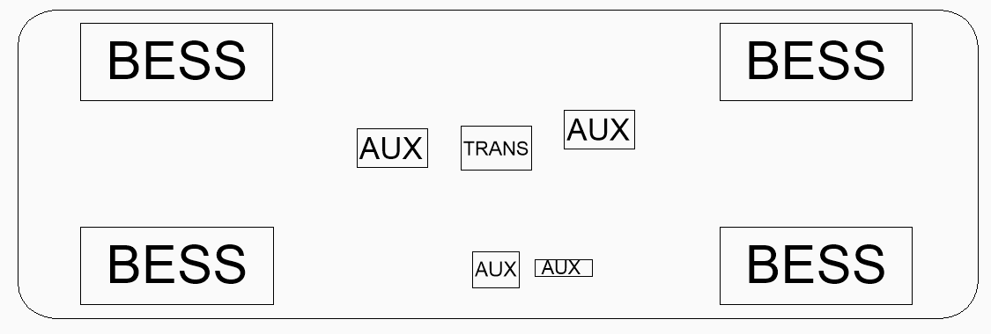

Figure 1, displacement of a group of BESS units

Because inside a plant there are several groups of BESS units arranged in a grid, the analysis has been extended also including in the simulation domain one of the BESS units from a nearby group.

The fire has been modelled defining a specific heat release rate (HRRPUA) of 1794 kW/m2 (Cigré 2013), applied to a 2,2x1,4 m oil pool below the transformer and to the two faces of the solid envelope representing the transformer that are facing the nearest BESS, obtaining a 16 MW HRR, modelled as a constant value.

To calculate the fire duration, at first the available energy has been calculated, multiplying the total amount of oil, 1805 kg, times its heat of combustion, 46 MJ/kg, obtaining a total energy of 83,030 MJ.

Dividing it by the HRR, a duration of 5,189 seconds has been obtained.

A BESS structure is made of two layers of 2 mm thick steel with 50 mm of insulating rock wool interposed, so those of interest have been modelled as layered surfaces in order to let FDS calculate the heat transmission through the external surfaces.

Also, the inside of a BESS is divided into three volumes: the first one, closer to the fire, is 25 cm wide and is used to house the electrical equipment for external connections, the second one is the main one and contains the battery racks, while the last one contains the HVAC device (not modelled).

Also, the wall that separates the first two is made of two layers of steel with 50 mm of rock wool interposed.

A number of wall temperature and gas temperature sensors have been placed to keep track of the temperatures evolving on the shell surfaces and inside BESS units.

In Figure 2 (left and center) the internal of a BESS is represented, along with some of the sensors; solid and wireframe representations are placed side by side in order to make the sensors positioning visible.

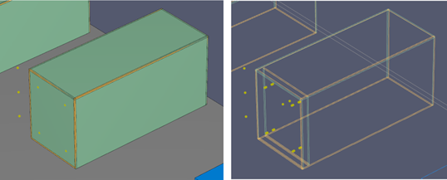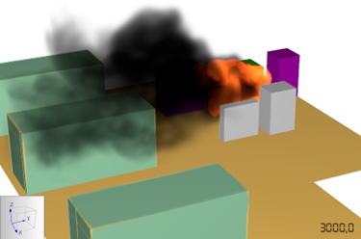

Figure 2, BESS model in FDS, solid view (left), wireframe view (center) and fire/smoke representation (right)

Sensors have been placed on both faces of the wall facing the fire, and on both faces of the wall dividing the two internal volumes. A gas temperature sensor has been placed in each of the two internal volumes. Atmospheric conditions have been set with wind blowing from the transformer towards the closer BESS, with a 5 m/s speed and Pasquill stability class D, in order to consider a worst-case scenario.

The modelled fire and smoke are reported in Figure 2 (right side).

Figure 3, Temperature chart for BESS n.2

The simulation has been stopped at 3,000 seconds, considering that the trends of the temperatures were almost linear; results have been elaborated and some charts have been prepared plotting linear trendlines.

In Figure 3 the following temperatures are reported:

* WT-B2-PE-E3: surface temperature of external side of wall facing the fire;
* TD-B2-1: air temperature inside the intermediate volume of BESS enclosure;
* TD-B2-1: air temperature inside the battery compartment of BESS enclosure.
  1. Explosion scenario

The explosion scenario has been modelled on the basis of the off-gases composition, defining an empirical formula to characterize it.

The same scenario has been developed considering two different spacings between adjacent containers: 6m and 8 m.

It has been assumed that one cell went into thermal runaway, thus considering the amount of off-gases coming from one cell, and assuming the formation an air/off-gases mixture in stoichiometric concentration.

A retarded ignition has been supposed, then analyzing the scenario with exploCFD, an highly validated hybrid analytical-CFD model developed by Advanced Analysis Australia.

An example of the obtained results is reported in Figure 4 and Figure 5. In the former the overpressure in a given moment is shown in color-scale in a layout view. The latter shows a chart of the overpressure along the exposed wall of the target BESS.

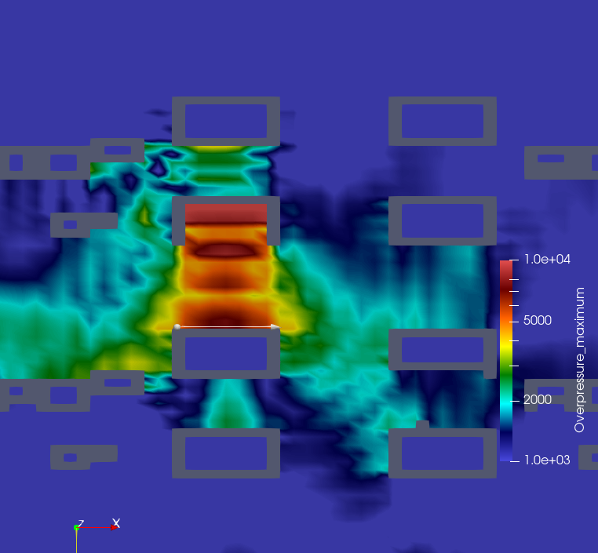

Figure 4, maximum overpressures for the explosion scenario, 6 m spacing

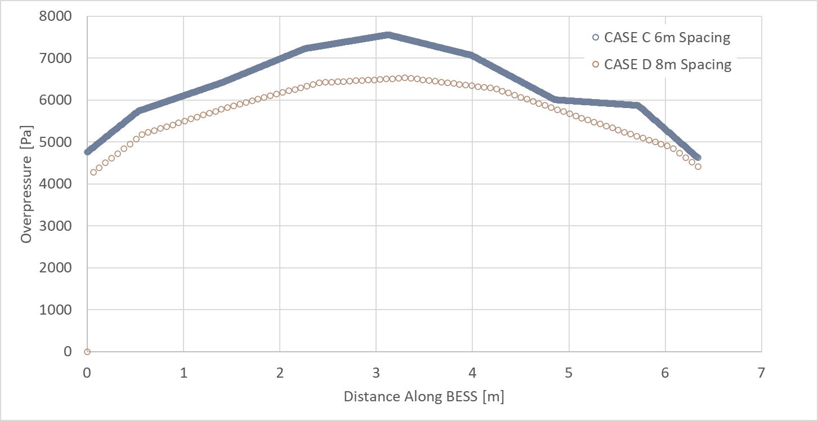

Figure 5, maximum overpressures for the explosion scenario, 6 m spacing

It can be seen that the maximum overpressure at the BESS closest to the one in which the explosion occurs reaches a peak level of 7.5 kPa for the 6 m spacing case.

This value has been compared with those found in Barowy et al., 2022, here under reported:

* 2-4 kPa, overpressure causing the container doors to collapse;
* 40-60 kPa, overpressure causing permanent deformation of the container walls and ceiling
* >70 kPa, overpressure causing the container doors and other solid fragments to be projected.

The calculated value is slightly above the first threshold (4 kPa), thus indicating that the target BESS would probably will undergo some level of damage not only to the doors but also to the structure.

* 1. Conclusions

On the left side of the bow-tie diagram for the operational phase a number of faults have been identified, and related barriers have been considered.

A detailed study has been carried out for the external fire scenario due to dielectric oil release (1805 kg) from the transformer in a group of four BESS units, and for the internal explosion scenario.

In particular, the effectiveness of two barriers have been analyzed:

* Separation distance between BESS units and electric transformer
* Structural characteristics of the BESS walls

The analyses for the transformer fire scenario showed that the temperatures of the external side of the most exposed wall reached about 250 °C due to the interposed separation distance (5 m); the presence of an intermediate technical volume and the thermal insulation of the walls avoided a significant rise of the air temperature inside the batteries room, that reached a temperature of about 30 °C.

Such a temperature is not critical and cannot be a cause of thermal abuse (Quan et al, 2022), which can lead to a thermal runaway reaction.

The explosion analysis showed that the overpressure affecting the BESS next to the one in which the explosion occurs reaches a peak of 7.5 kPa for the 6 m distance case, which would probably cause some non-catastrophic damage to the BESS structure. This confirmed the distances now prescribed in the existing standards.

It has to be noted that, given the focus on safety aspects from fire and explosion threats, the conducted assessment should be coupled and completed with an environment impact assessment that considers potential effects coming from off-gases dispersion and fire protection water discharge on the soil.

References

Snyder M. D., 2024, Managing the hazards of lithium-Ion Battery Systems, CEP

Soumyoraj M., Debabrata G.,2023, Thermal behaviour and thermal runaway propagation in lithium-ion battery systems – A critical review, Journal of Energy Storage 62, Elsevier, Amsterdam

Conzen, S. Lakshmipathy, A. Kapahi, S. Kraft, M. DiDomizio, 2023, Lithium-ion battery energy storage systems (BESS) hazards, Journal of Loss Prevention in the Process Industries n. 81/2023, Elsevier, Amsterdam

Fiorentini L., 2021, Bow-Tie Industrial Risk Management Across Sectors: A Barrier-Based Approach, Wiley, New York

Cigré, 2013, WG A2-33 Guide for Transformer Fire Safety Practices

Quan X., Yi R., Zili W., Dezhen Y., Peiyu Y., Zeyu W., Bo S., Qiang F., Cheng Q., 2023, Safety risk assessment method for thermal abuse of lithium-ion battery pack based on multiphysics simulation and improved bisection method, Energy, Elsevier, Amsterdam

Fiorentini L., Marmo L., 2018 Sound barriers management in process safety: bow-tie approach according to the first official aiche - ccps guidelines, Chemical Engineering Transactions, 67, 253-258

Dattilo F., Fiorentini L., 2024, The application of the Italian Fire Code (IFC) to Battery Energy Storage Systems (BESS), SFPE Europe

A. Barowy et al., 2022, Explosion protection for prompt and delayed deflagrations in containerized lithium-ion battery energy storage systems